
A10
Sreenidhi Institute of Science & Technology
(An Autonomous Institution)
Code No: 101MA07/111MA07
B. TECH. II – Year I – Semester Examinations, MAY/JUNE, 2014 (Supplementary)
NUMERICAL METHODS & PARTIAL DIFFERENTIAL EQUATIONS (CSE & IT)

Time: 3 Hours Max. Marks: 70

Note: No additional answer sheets will be provided.

Part - A (Objective Type)
Max.Marks:20

Answer all QUESTIONS.

- Explain the quadratic interpolation.
- Derive the relationship between and E, where 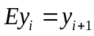and 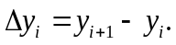
- To fit a second degree parabola, write the normal equation from the following data:
X | 1 | 3 | 5 | 7 | 9
Y | 2 | 7 | 10 | 11 | 9
- Give the relationship between correlation and regression.
- Solve 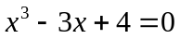for the root which lies between 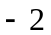 and 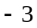 using the Regula-Falsi’s method three times in succession.
- Write the iterative formula using Newton-Raphson’s method for e^{-x} = sin y, for the root lying between 0 and 1.
- Derive the formula 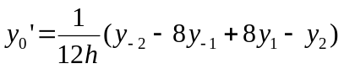.
- Derive Simpon’s three-eighth rule from the Newton-Cote’s formula.
- Obtain a partial differential equation from 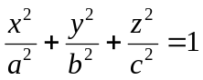.
- Given that 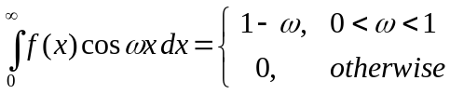. Find f(x).

Part – B
Max. Marks: 50

ANSWER ANY FIVE QUESTIONS. EACH QUESTION CARRIES 10 MARKS

- a. Using Lagrange’s interpolation formula, find the value of y corresponding to x = 10 from the following table
x | 5 | 6 | 9 | 11
y | 12 | 13 | 14 | 16

b. Solve e^{x} = 3.14 by inverse interpolation using x = f(y) with f(3.0) = 1.0986, f(3.2)=1.1632 and f(3.4) = 1.2238.

- a. R is the resistance to maintain a train at speed V; find a law of the R = a+bV² connecting R and V, using the following data:
V (miles / hour) | 10 | 20 | 30 | 40 | 50
R(lb/ton) | 8 | 10 | 15 | 21 | 30

b. Following records are available: Regression equations: 8x - 10y + 66 = 0, 4x - 18y = 214 and 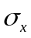= 3. Find (i) mean values of x and y (ii) , and (iii) coefficient of correlation.

- a. Solve 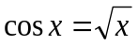by the method of false position.
b. Setup an iteration process for the equation 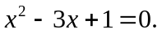

- a. Compute 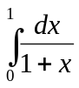to six decimal places using Simpson’s rule.
b. Evaluate 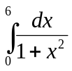by using Trapezoidal rule.

- a. Find a solution if 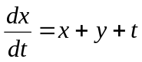and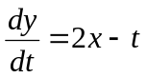given that x = 0, y = 1 when t = 1, as the power series in t for x and y by using Taylor’s method.
b. Using modified Euler’s method, find y(0.2) and y(0.4) given 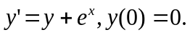

- a. Solve 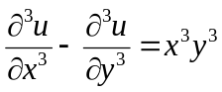.
b. Solve (x+y)(p+q)²+(x-y)(p-q)²=1.

- a. Solve the equation 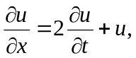given u(x, 0) = 6e^{-3x} by the method of separation of variables. [5]
b. Solve 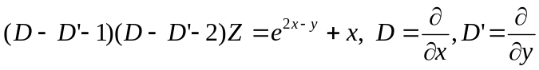.

8. a. Find the Fourier sine transform of e^{-ax}, a>0. Hence evaluate 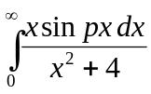, p>0.

b. The temperature at one end of a bar of 20cm long and with insulated sides, is kept at zero degree Celsius and that at the other end is kept at 60 degree Celsius, until steady state conditions prevail. The two ends are then suddenly insulated, so that the temperature gradient is zero at each end thereafter. Find the temperature distribution in the bar.

-- 00 -- 00 --

